Write a Python program to perform arithmetic operations on integers.
Code :
print("Name : Alisha Khan")
print("Objective : Program to perform arithmetic operation on integers")
print()

#input two integer value
num1 = int(input("Enter First Integer : "))
num2 = int(input("Enter Second Integer : "))
print()
print("Performing arithmetic operation on entered integers : ")
def arithmetic_op(a,b) :
addition = a + b
subtraction = a - b
multiplication = a * b
division = a / b
floor_division = a // b
modulus = a % b
exponentiation = a ** b

print("Additon : ", addition)
print("Subtraction : ", subtraction)
print("Multiplication : ", multiplication)
print("Division : ", division)
print("Floor Division : ", floor_division)
print("Modulus : ", modulus)
print("Exponentiation : ", exponentiation)

arithmetic_op(num1, num2)

Output :

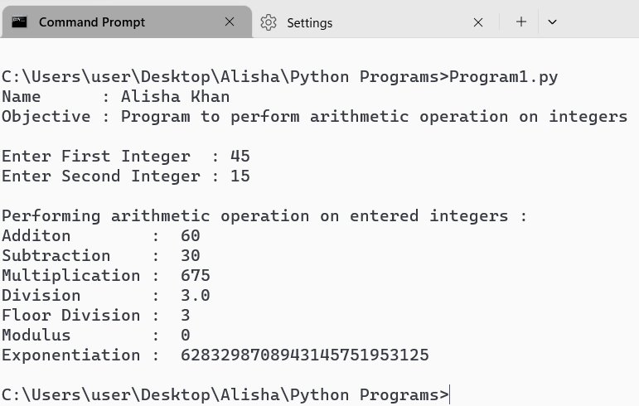

Write a Python program to check and print the types of at least 5 different inbuilt objects.
Code :

print("Name : Alisha Khan")
print("Objective : check and print the types of in built objects.")
print()
int_var = 10
print("Type of ", int_var, "is : \n", type(int_var))

float_var = 3.14
print("Type of ", float_var, "is :", type(float_var))

string_var = "Hello World"
print("Type of ", string_var, "is :", type(string_var))

tuple_var = (11, 22, 33, 44, 55)
print("Type of ", tuple_var, "is :", type(tuple_var))

dict_var = {"Name": "Alisha", "Age": "22"}
print("Type of ", dict_var, "is :", type(dict_var))

bool_var = True
print("Type of ", bool_var, "is :", type(bool_var))

Output:

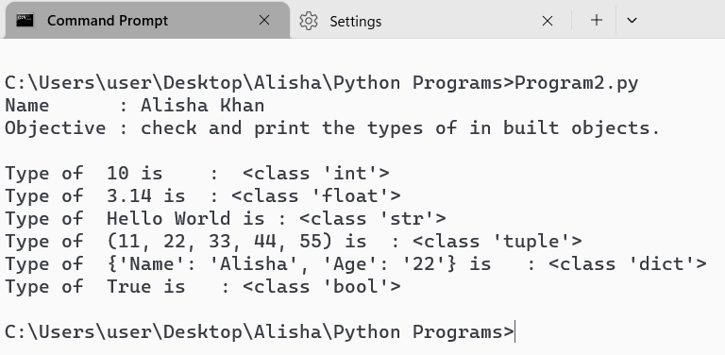

Write a Python program to check if a number is EVEN or ODD.

Code :
print("Name : Alisha Khan")
print("Objective : Check the mnumber is Even or Odd.")
print()
def check(number) :
if number % 2 == 0 :
print(number, " is an EVEN number.")
else :
print (number, " is an ODD number.")

num = int(input("Enter an enteger : "))
check(num)

Output :

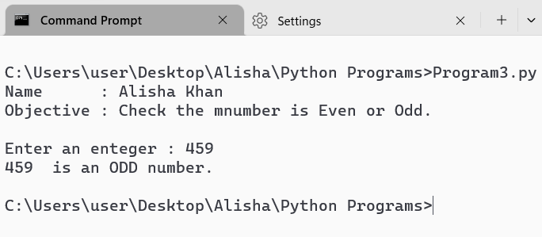

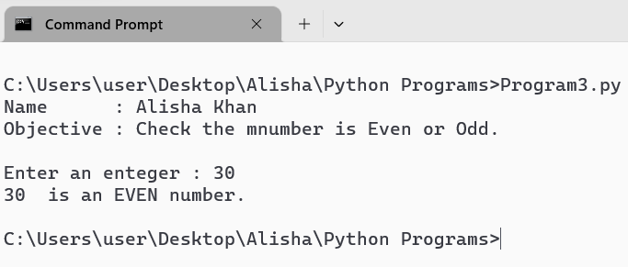

Write a Python program to check if a number is Positive, Negative or Zero.

Code :

print("Name : Alisha Khan")
print("Objective : Check if a number is Positive, Negative or Zero.")
print()

number = int(input("Enter a number : "))

def check(num) :
if (num < 0 ) :
print(num, " is a Negative Number.")
elif (num >= 1) :
print(num, " is a Positive Number.")
else :
print("Entered Number is Zero.")

check(number)

Output :

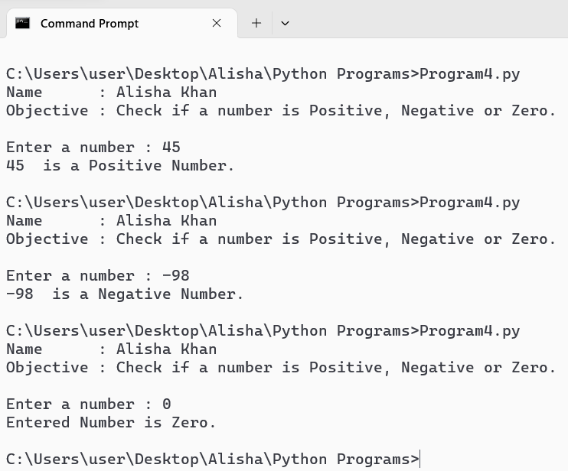

Write a Python program to check if a number is PRIME or NOT

Code :
print("Name : Alisha Khan")
print("Objective : Check if a number is Prime or not.")
print()

number = int(input("Enter a number : "))

def check(num) :
if (num <= 1) :
print(num, " is not a PRIME NUMBER.")
elif (num == 0) :
print("You entered ZERO.")
elif (num == 2 ) :
print(num, " is a PRIME NUMBER.")
elif (num % 2 == 0) :
print(num, " is not a PRIME NUMBER.")
else :
print(num, " is a PRIME NUMBER.")

check(number)

Output :

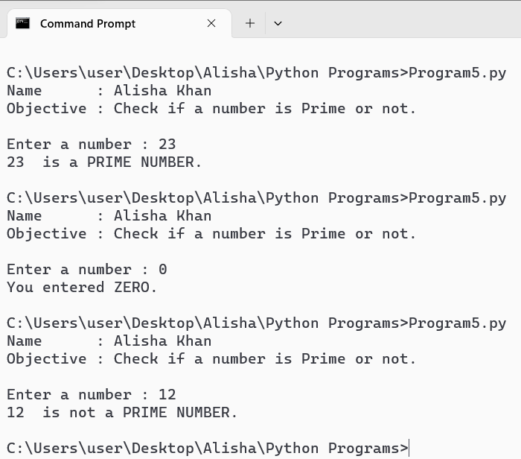

Write a Python program to check whether a string entered by the user is a valid decimal number or not.

Code :
print("Name : Alisha Khan")
print("Objective : Check if a string is a valid decimal number or not.")
print()

user_input = input("Enter a string : ")

if user_input.isdecimal() :
print(user_input, " is a valid Decimal Number.")
else :
print(user_input, " is not a valid Decimal Number")

Output :

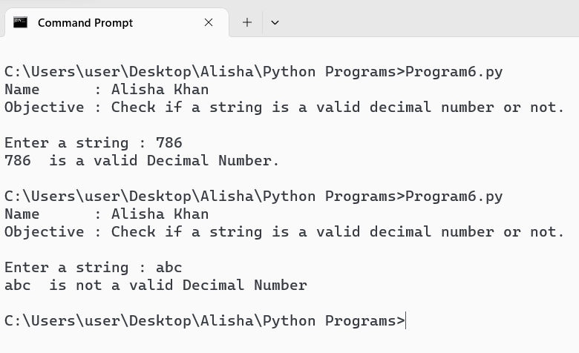

Write a Python program to check if a year entered by the user is a Leap Year or NOT.

Code :
print("Name : Alisha Khan")
print("Objective : Check if a year is Leap Year or Not.")
print()

year = int(input("Enter a year : "))

def check(year) :
if (year%4 == 0 and year%100 != 0) or (year%400 == 0) :
print(year, " is a Leap Year.")
else :
print(year, " is not a Leap Year.")

check(year)

Output :

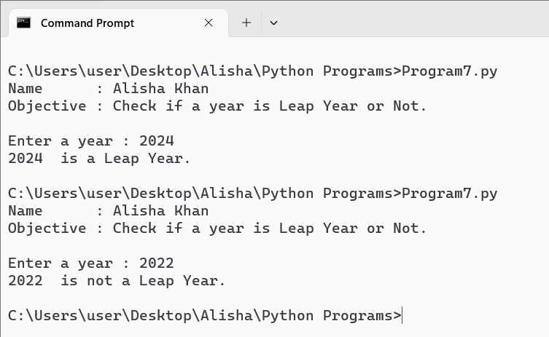

Write a Python program to check whether a string entered by the user is a palindrome or not.

Code :
print("Name : Alisha Khan")
print("Objective : Check if a string is Palindrome and print its reverse.")
print()

def palindrome(str):
str = str.replace(" ", "").lower()
return str == str[::-1]

string = input("Enter a string: ")
reversed_string = string[::-1]

print("Reverse of the string is:", reversed_string)

if palindrome(string):
print("YES", string, "is a Palindrome.")
else:
print("NO", string, "is not a Palindrome.")

Output :

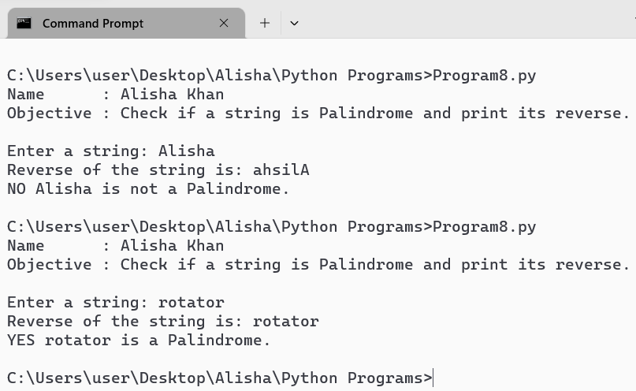

Write a Python program to get a Decimal number from user and convert it into Binary, Octal and
Hexadecimal.

Code :
print("Name : Alisha Khan")
print("Objective : Convert Decimal into Binary, Octal and Hexadecimal.")
print()
number = int(input("Enter a Decimal Number : "))

bin_number = bin(number)
octal_number = oct(number)
hexa_number = hex(number)

print("Binary Representation of ", number, " is : ",bin_number)
print("Octal Representation of ", number, " is : ",octal_number)
print("Hexadecimal Representation of ", number, " is : ",hexa_number)

Output :

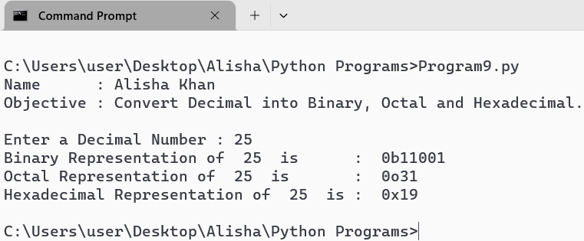

Write a Python Program to find sum of natural numbers up to N.

Code :
print("Name : Alisha Khan")
print("Objective : Sum of Natural Numbers, Upto N.")
print()
number = int(input("Enter the value of N : "))
sum = 0

for i in range(1, number+1) :
sum += i

print("The sum of ",number ," Natural number is : ", sum)

Output :

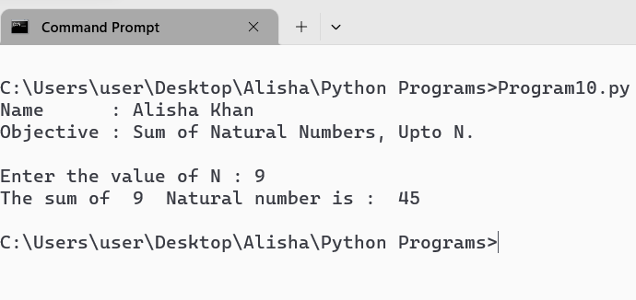

Write a Python Program to get marks in five subjects from user and calculate average marks,
percentage and grade of a student.
Code :
print("Name : Alisha Khan")
print("Objective : Program to calculate average marks, percentage and grade.")
print()
print("Enter Marks for each subject out of hundred: ")
Python = float(input("Python : "))
DSA = float(input("DSA : "))
Java = float(input("Java : "))
ACA = float(input("ACA : "))
Data_Mining = float(input("Data Mining :"))

Total = Python + DSA + Java + ACA + Data_Mining
print()
print("Result : ")
average = Total / 5
print("Average marks : ", average)
percentage = (Total / 500) * 100
print("Percentage : ", percentage, " %")

if percentage >= 90 :
grade = 'A+'
elif percentage >= 80 :
grade = 'A'
elif percentage >= 70 :
grade = 'B'
elif percentage >= 60 :
grade = 'C'
elif percentage >= 50 :
grdae = 'D'
else :
grade = 'Fail'
print("Grade : ", grade)

Output :

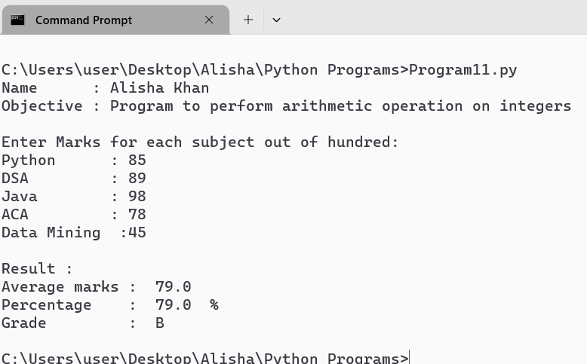

Write a Python program to get a number and find the sun and product of its digit.
Code :
print("Name : Alisha Khan")
print("Objective : To find sum and product of digits of a number")
print()
num = int(input("Enter a number : "))
number = num
sum = 0
product = 1

#Use a loop to iterate over each digit of the number
while num > 0 :
#get the last digit of number
last_digit = num % 10

#add the last_digit to sum and multiply it to the product
sum += last_digit
product *= last_digit

#Remove the last digit from the number
num //= 10

#print the result
print()
print("Sum of the digits of ", number, " is : ", sum)
print("Product of the digits of ", number, " is : ", product)

Output :

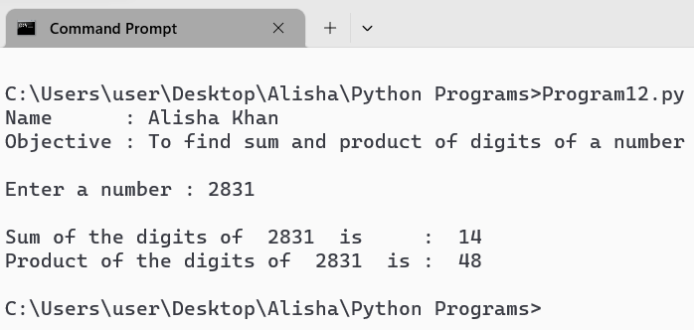

Write a Python program to get two integer and find their GCD and LCM.

Code :
print("Name : Alisha Khan")
print("Objective : To find GCD/HCF and LCM of two integers")
print()
num1 = int(input("Enter first integer : "))
num2 = int(input("Enter second integer : "))

#Function to find GCD of two numbers
def gcd( A,B ) :
while B != 0 :
A,B = (B, A % B)
return A

#Function to find LCM of two numbers
def lcm(A,B) :
return(A * B) // gcd(A, B)

#Calculating GCD and LCM
gcd_value = gcd(num1, num2)
lcm_value = lcm(num1, num2)

#print the result
print("\nRESULTS : ")
print("GCD of ", num1, " and ", num2, " is : ", gcd_value)
print("LCM of ", num1, " and ", num2, " is : ", lcm_value)

Output :

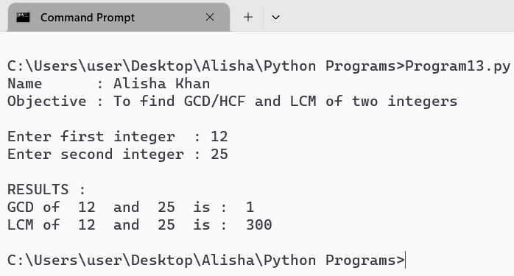

Write a Python program to find factorial of a number using while loop.

Code :
print("Name : Alisha Khan")
print("Objective : To find Factorial of a number using while loop")
print()
num = int(input("Entef a number : "))

def Fact(N) :
if N < 0 :
raise ValueError("Factorial is not defined for negative numbers!")
factorial = 1
current = N
while current > 1 :
factorial *= current
current -= 1
return factorial

#print the result
Result = Fact(num)
print("Factorial of ", num, " is : ", Result)

Output :

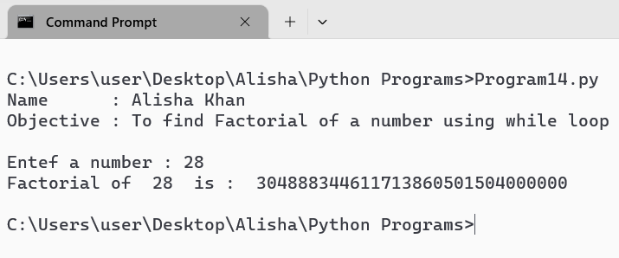

Write a Python program to print Fibonacci series up to N terms.

Code :
print("Name : Alisha Khan")
print("Objective : To print Fibonacci series upto N terms.")
print()
terms = int(input("Enter the number of terms : "))

#initializing first two terms
a = 0
b = 1

print("Fibonacci series upto ", terms, " terms : ")
for i in range (terms) :
print(a, end = " ")
c = a + b
a = b
b = c

print()

Output :

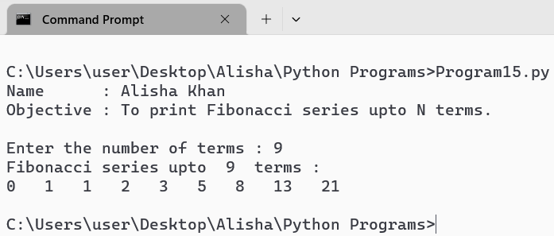

Write a Python program to print multiplication table.

Code :
print("Name : Alisha Khan")
print("Objective : To print Multiplication table .")
print()
num = int(input("Enter a number to get multiplication table : "))
print()
print("Multiplication table of ", num, " is : ")
for i in range(1, 11) :
print(num ," X ", i , " = ", num * i)

Output :

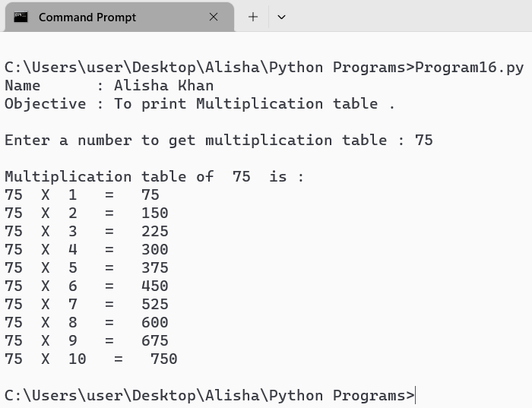

Write a Python program to access a string in forward and backward orders using the “While”
loop.

Code :
print("Name : Alisha Khan")
print("Objective : Access string in forward and backward direction using while loop")
print()
string = input("Enter a String : ")
index = 0
print()
#Printing the string in Forward and Bckward Direction
print("Forward Direction : ")
while index < len(string) :
print(string[index], end = " ")
index += 1
print()

print("Backward Direction : ")
index = len(string) - 1
while index >= 0 :
print(string[index], end = " ")
index -= 1

Output :

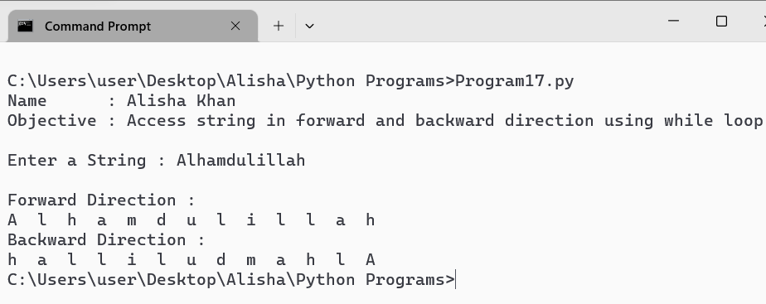

Write a Python program to access a string in forward and backward orders using the “for” loop.

Code :
print("Name : Alisha Khan")
print("Objective : Access string in forward and backward direction using for loop.")
print()
string = input("Enter a String : ")
print()
#Printing the string in Forward and Bckward Direction
print("\nForward Direction : ")
for char in string :
print(char , end = " ")
print()

print("Backward Direction : ")
for char in reversed(string) :
print(char, end = " ")

Output :

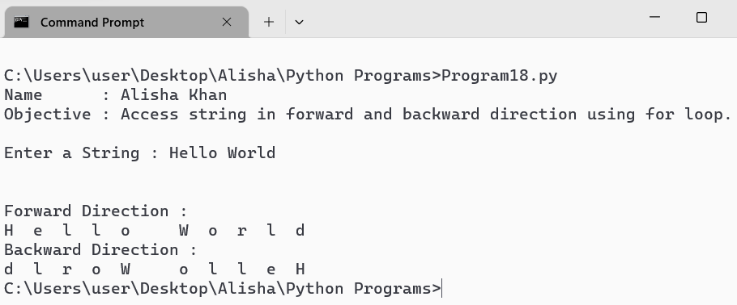

Write a Python program to find whether a substring exists in main string or not.

Code :
print("Name : Alisha Khan")
print("Objective : To find whether a substring exists in main string.")
print()
main_string = input("Enter the main string : ")
sub_string = input("Enter the sub string :")
print()
#check if the sub string exists in the main string
if sub_string in main_string :
print("The sub string ", sub_string, " exists in the main string ", main_string )
else :
print("The sub string ", sub_string, " does not exists in the main string ", main_string )

Output :

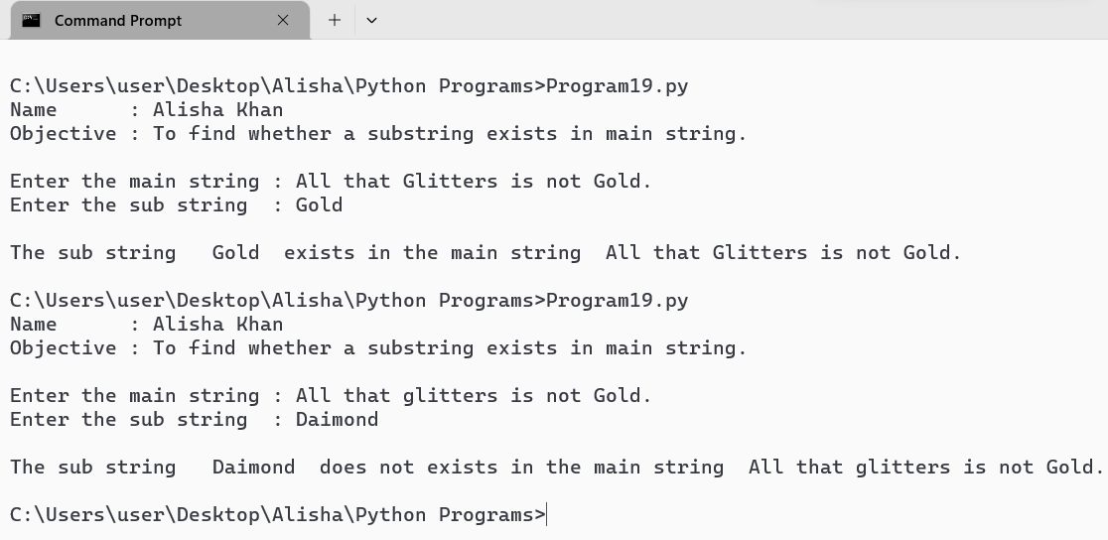

Write a Python program to find the first occurrence of a substring in the main string.

Code :
print("Name : Alisha Khan")
print("Objective : To find the first occurence of a substring in the main string.")
print()
main_string = input("Enter the main string : ")
sub_string = input("Enter the sub string :")
print()

#Find the first occurence of the sub string in the main string
index = main_string.find(sub_string)

if index != -1 :
print("The sub string ", sub_string, " was found in the main string ", main_string, " at index ", index)
else :
print("The sub string ", sub_string, " was not found in the main string ", main_string)

Output :

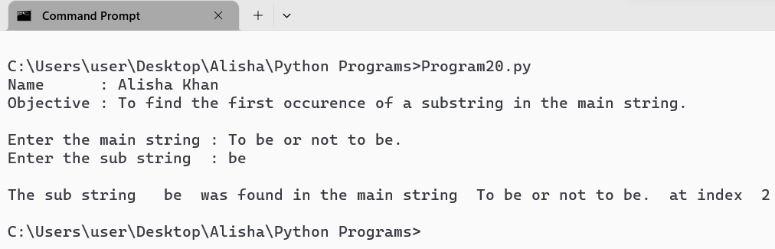

Write a Python program to count the number of times a substring appears in the main string.

Code :
print("Name : Alisha Khan")
print("Objective : To count the number of times a substring \n\t\tappears in the main string.")
print()
main_string = input("Enter the main string : ")
sub_string = input("Enter the sub string :")
print()

#count the number of occurences of the sub string in the main string
count = main_string.count(sub_string)

#print the result
print("The sub string ", sub_string, " appears ", count, " times in the main string ")

Output :

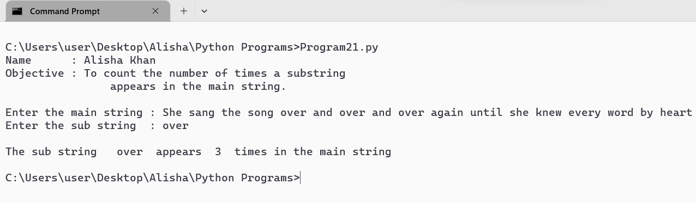

Write a Python program to demonstrate the use of all “casting” methods and display a string in
different cases.

Code :
print("Name : Alisha Khan")
print("Objective : Demonstrate the use of all casting methods.")
print()
input_string = input("Enter a string : ")
print()
print("Displaying the entered string in different cases : ")
print()
def display(string) :
print("1. Original String : {}".format(string))
print("2. Uppercase : {}".format(string.upper()))
print("3. Lowercase : {}".format(string.lower()))
print("4. Title Case : {}".format(string.title()))
print("5. Capitalized Case : {}".format(string.capitalize()))
print("6. Swapcase : {}".format(string.swapcase()))

display(input_string)

Output :

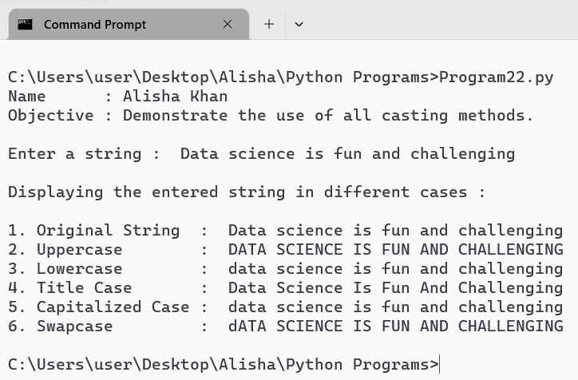

Write a Python program to demonstrate the use of all string testing { isXXX() } methods.

Code :
print("Name : Alisha Khan")
print("Objective : Demonstrate use of all string testing methods.")
print()

sample_string = "Alisha"
print("isalnum() :", sample_string.isalnum())
print("isalpha() :", sample_string.isalpha())
print("isdecimal() :", sample_string.isdecimal())
print("isdigit() :", sample_string.isdigit())
print("islower() :", sample_string.islower())
print("isnumeric() :", sample_string.isnumeric())
print("isspace() :", sample_string.isspace())
print("istitle() :", sample_string.istitle())
print("isupper() :", sample_string.isupper())

Output :

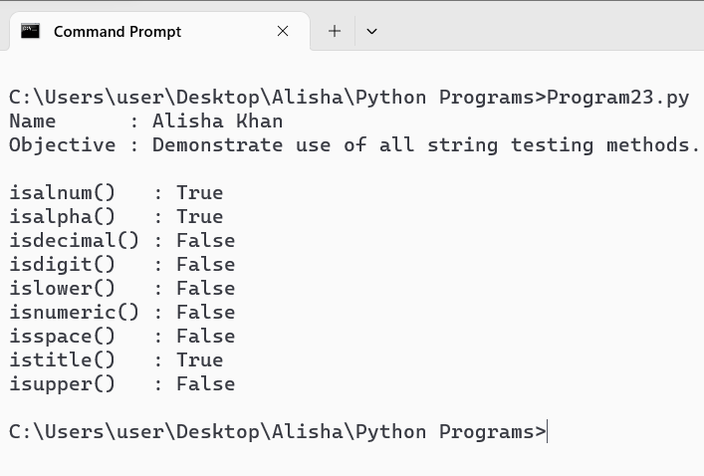

Write a Python program to take a list of integers as input and return the average.

Code :
print("Name : Alisha Khan")
print("Objective : Take list of integers and return the average.")
print()
def average(list) :
if len(list) == 0 :
return 0
else :
return sum(list) / len(list)

def main() :
try :
list = []
while True :
num = input("Enter an integer (or 'done' to finish) : ")
if num.lower() == 'done':
break
list.append(int(num))

avg = average(list)
print("\nAverage of elements of list : ", avg)

except ValueError:
print("Please enter valid integers.")

main()

Output :

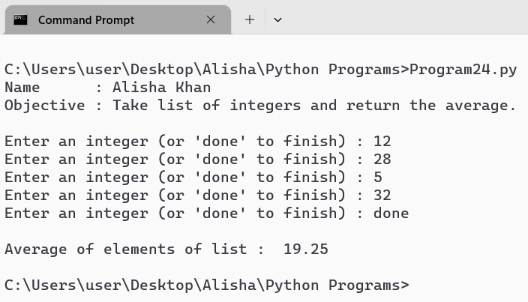

Write a Python program to take two distinct integers as input and print all prime numbers
between them.

Code :
print("Name : Alisha Khan")
print("Objective : To print Prime Numbers between two given numbers.")
print()

num1 = int(input("Enter First number : "))
num2 = int(input("Enter Second number : "))
print()
print("Prime numbers between ", num1, " and ", num2, " are : ")
if num1 > num2 :
num1, num2 = num2, num1

for j in range(num1+1, num2) :
count = 0
if j > 1 :
for i in range (1, j+1) :
if (j % i == 0 ) :
count = count +1
if count == 2:
print(j, end = " ")
print()

Output :

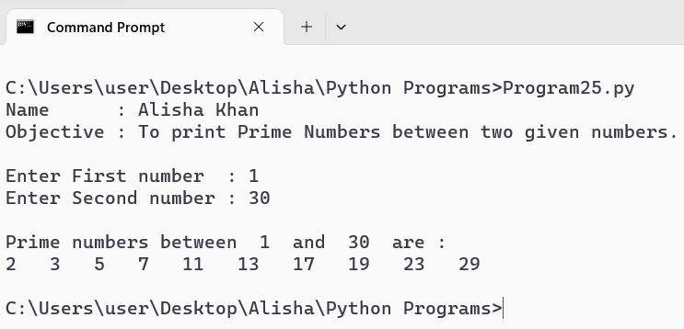

Write a Python function to take two integers as input and return both their sum and product.

Code :
print("Name : Alisha Khan")
print("Objective : Function to print sum and product of two integers.")
print()
def sp(a, b) :
sum = a + b
product = a * b
return sum, product

num1 = int(input("Enter First integer : "))
num2 = int(input("Enter Second integer : "))
print()
result = sp(num1, num2)
print("Sum of ", num1, " and ", num2, " is : ", result[0])
print("Product of ", num1, " and ", num2, " is : ", result[1])

Output :

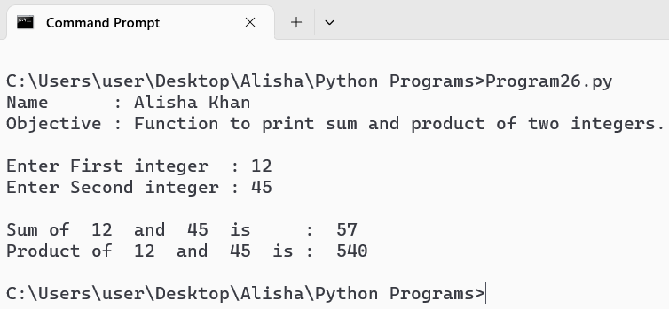

Write a Python program to demonstrate the positional arguments of a function.

Code :
print("Name : Alisha Khan")
print("Objective : Demonstrate positional arguments of a function.")
print()
def book(title, author, year) :
print(f"Title : {title}")
print(f"Author : {author}")
print(f"Year : {year}")

#calling the function with positional arguments
print("Correct Order of Positional Arguments :")
book("To kill a Mockingbird", "Harper Lee", 1960)
print()
print("Swapping Year and Author (Incorrect Usage) :")
book("To kill a Mockingbird", 1960, "Harper Lee")
print()
print("Swapping Title and Year (Incorrect Usage):")
book(1960, "Harper Lee", "To kill a Mockingbird")
print()

Output :

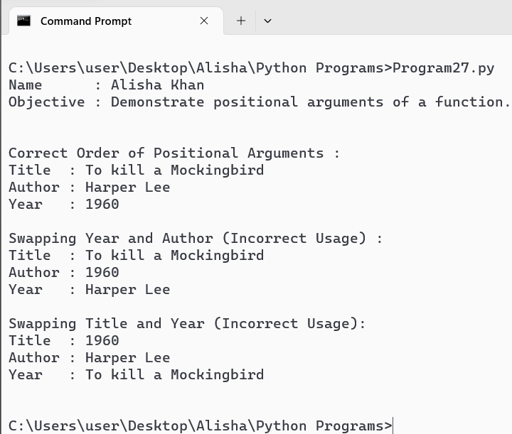

Write a Python program to demonstrate the keyword arguments of a function.

Code :
print("Name : Alisha Khan")
print("Objective : Demonstrating Keyword arguments of a function.")
print()

def Student(name, age, grade, city):
print(f"Name : {name}")
print(f"Age : {age}")
print(f"Grade : {grade}")
print(f"City : {city}")

print("Demonstrating Keyword Arguments:")
Student(name="Alisha", age=23, grade="A", city="Raipur")
print()
Student(city="Raipur", grade="A", name="Juhi", age=21)
print()
print("Mixing Arguments:")
Student("Keshar", age=22, grade="A", city="Raipur")

Output :

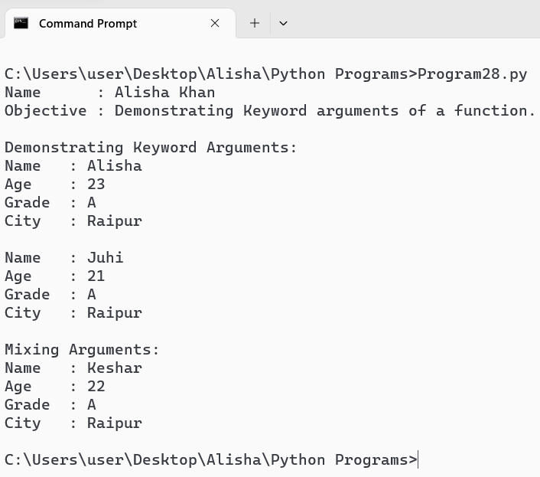

Write a Python program to demonstrate the default arguments of a function.

Code :
print("Name : Alisha Khan")
print("Objective : Demonstrating default arguments of a function.")
print()
def area(length=1, width=1) :
area = length * width
return area

print("Demonstrating default Arguments :")
print("Area of a 1x1 square : ", area())
print("Area of a 2x1 square : ", area(2))
print("Area of a 3x4 square : ", area(3, 4))

Output :

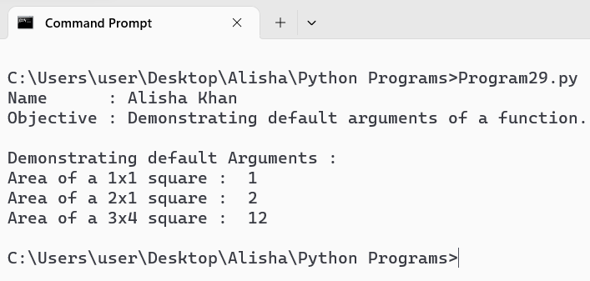

Write a Python function to demonstrate variable length arguments.

Code :
print("Name : Alisha Khan")
print("Objective : Demonstrating variable length arguments.")
print()
def var_length(*args) :
print("Number of arguments : ", len(args))
print("Arguments : ")
for arg in args :
print(arg)
#calling function
var_length(1, 2, 3, 4)
print()
var_length('Sapiens', 'The power of myth', 'The tao of Physics')
print()
var_length(True, False)

Output :

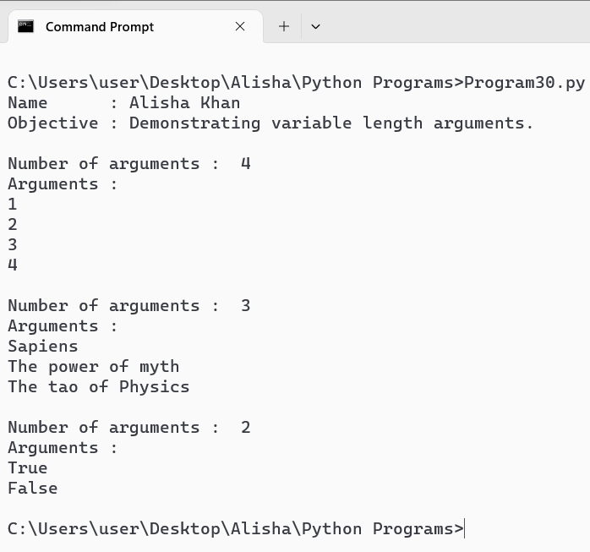

Write a Python function to demonstrate keyword variable length arguments.

Code :
print("Name : Alisha Khan")
print("Objective : Demonstrating keyword variable length arguments.")
print()
def keyword(**kwargs):
print("Number of keyword arguments:", len(kwargs))
print("Keyword arguments:")
for key, value in kwargs.items():
print(f"{key} : {value}")

keyword(name="Amaan", age=20, city="Raipur")
print()
keyword(a=1, b=2, c=3, d=4)
print()
keyword()

Output :

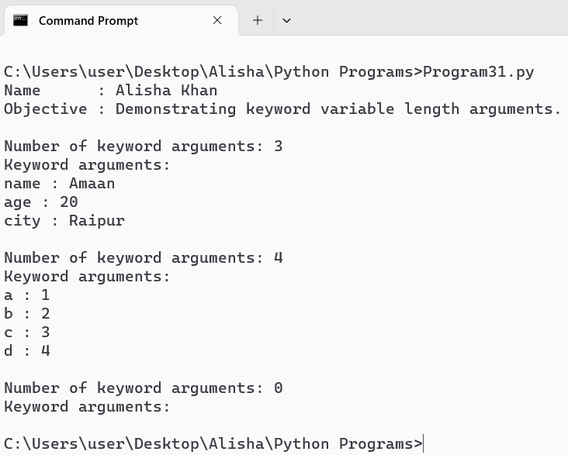

Write a Python program to demonstrate global and local variables.

Code :
print("Name : Alisha Khan")
print("Objective : Demonstrating Global and Local variables.")
print()

global_var = 20

def scope() :
local_var = 10
print("Local variable : ", local_var)
print("Global variable : ", global_var)

def modify_global() :
global global_var
global_var = 50
print("New value of Global variable : ", global_var)

print("Initial value of Global Variable : ", global_var)
print("\nCalling Scope() function : ")
scope()
print("\nCalling modify_global() function to modify the Global variable : ")
modify_global()
print("\nAgain calling the scope() function to check the value of Global variable :")
scope()
print("Global variable's value has been modified.")

Output :

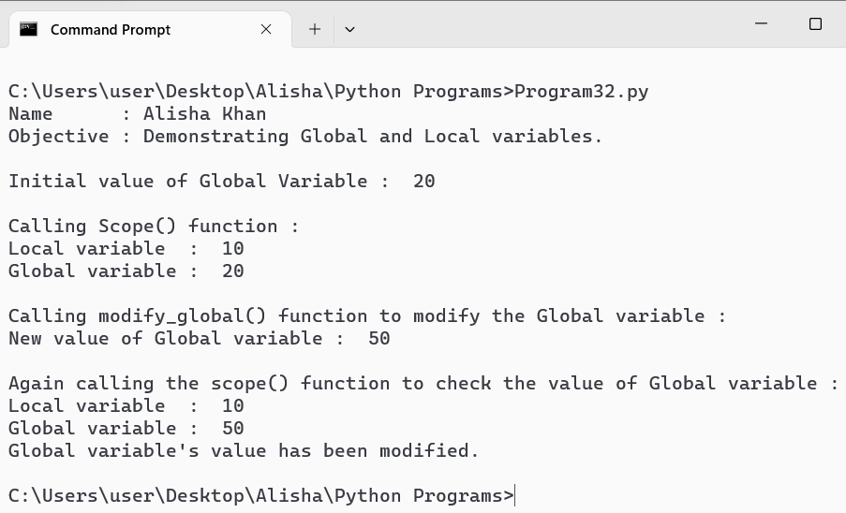

Write a Python function that takes an integer as input and calculates its factorial using recursion.

Code :
print("Name : Alisha Khan")
print("Objective : Calculate factorial of a number using recursion.")
print()
number = int(input("Enter a number : "))

def fact(num) :
if num == 0 or num == 1 :
return 1
else :
return num * fact(num-1)

Result = fact(number)
print("Factorial of ", number, " is : ", Result)

Output :

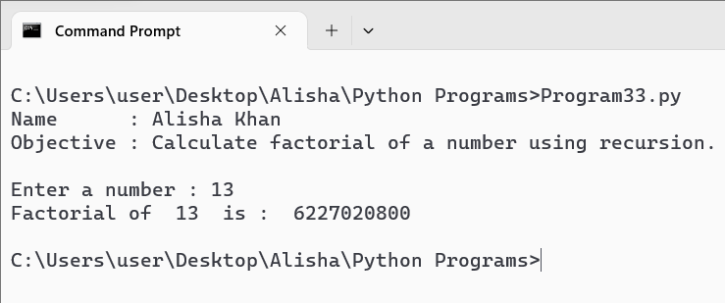

Write a Python program to demonstrate the use of lambda functions.

Code :
print("Name : Alisha Khan")
print("Objective : Demonstrate use of lambda functions.")
print()

#Example 1 : Basic Lambda Function
add = lambda x, y : x + y
print(f"Addition using lambda : 5 + 3 = {add(5, 3)}")
print()

#Example 2 : Using lambda with filter()
numbers = [1, 2, 3, 4, 5, 6, 7, 8, 9, 10]
even_num = list(filter(lambda x : x % 2 == 0, numbers))
print(f"Even numbers using filter and lambda : {even_num}")
print()

#Example 3 : Using Lambda with sorted() to sort
students = [
{'name' : 'Alisha', 'score' : 88},
{'name' : 'Juhi', 'score' : 72},
{'name' : 'Keshar', 'score' : 95}
]
sorted_students = sorted(students, key=lambda x : x['score'])
print("Students sorted by score using sorted and lambda : ")
for student in sorted_students :
print(student)

Output :

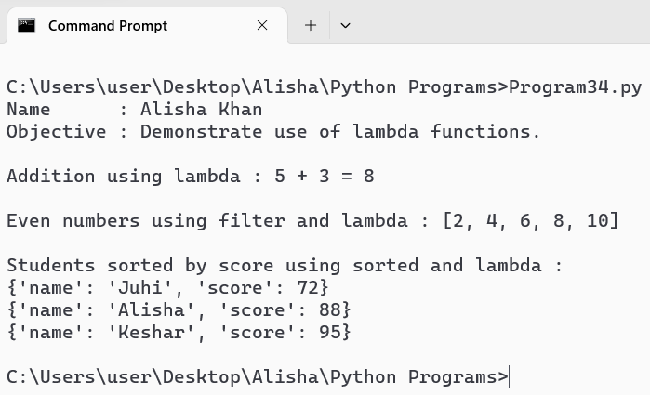

Write a Python program to demonstrate the use of lambda functions and map.

Code :
print("Name : Alisha Khan")
print("Objective : Demonstrate the use of lambda functions and map.")
print()

numbers = [1, 2, 3, 4, 5, 6, 7, 8, 9, 10]
print("Elements in list : ", numbers)
squared_num = list(map(lambda x : x ** 2, numbers))
print(f"Squared numbers using map and lambda : {squared_num}")
print()

Output :

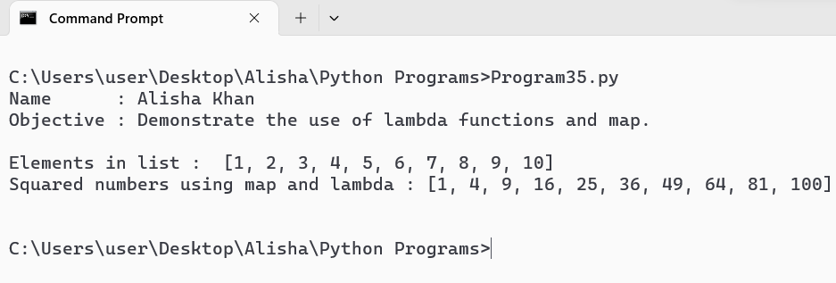

Write a Python program to demonstrate the use of lambda functions and reduce.

Code :
from functools import reduce

print("Name : Alisha Khan")
print("Objective : Demonstrate the use of lambda functions and reduce.")
print()
numbers = [1, 2, 3, 4, 5]
sum = reduce(lambda x, y : x + y, numbers)
print(f"Sum of {numbers} using reduce and lambda : {sum}")
print()

product = reduce(lambda x, y : x * y, numbers)
print(f"Product of {numbers} using reduce and lambda : {product}")
print()

Output :

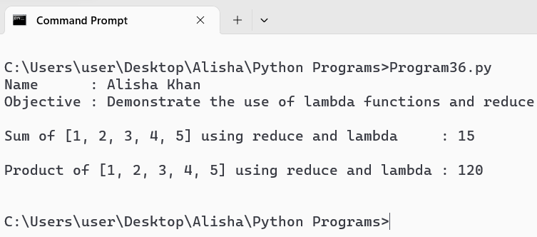

Write a Python program to demonstrate the various list processing methods.

Code :
print("Name : Alisha Khan")
print("Objective : Demonstrate various list processing methods.")
print()

my_list = []
print("Empty List : ", my_list)

print("\nAppend method : ")
my_list.append(10)
print("After append : ", my_list)
my_list.append(20)
print("After append(20):", my_list)

print("\nExtend method:")
my_list.extend([30, 40])
print("After extend([30, 40]): ", my_list)

print("\nInsert method : ")
my_list.insert(2, 25)
print("After insert(2, 25): ", my_list)

print("\nRemove method:")
my_list.remove(20)
print("After remove(20): ", my_list)

print("\nPop method : ")
pop = my_list.pop()
print("After pop() : ", my_list)

print("\nIndex method : ")
index = my_list.index(30)
print("Index of 30 : ", index)

print("\nCount method : ")
count = my_list.count(25)
print("Count of 25 : ", count)

print("\nSort method : ")
my_list.sort()
print("After sort() : ", my_list)

print("\nReverse method : ")
my_list.reverse()
print("After reverse() : ", my_list)

print("\nCopy method : ")
copied_list = my_list.copy()
print("After copy() : ", copied_list)

print("\nClear method :")
my_list.clear()
print("After clear() : ", my_list)

Output :

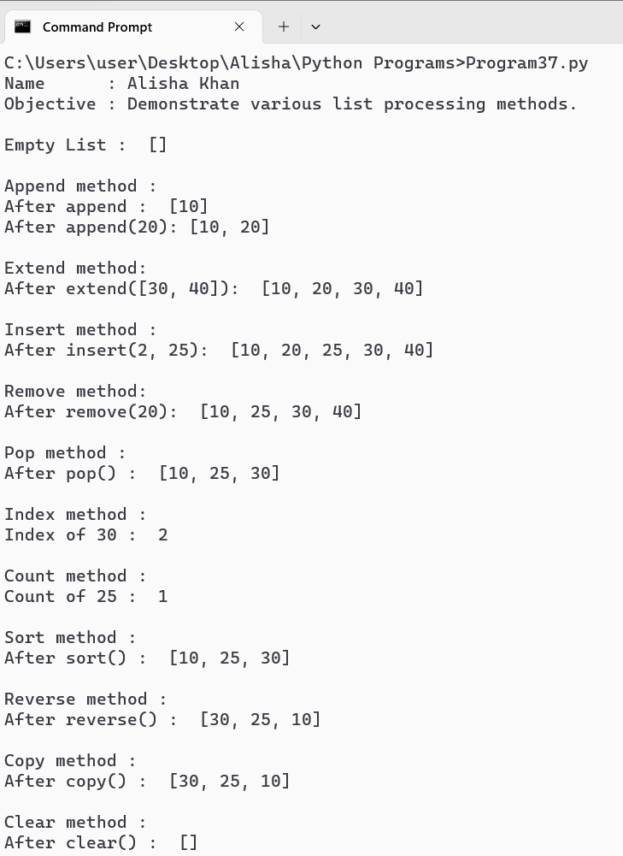

Write a Python program to find the biggest and smallest numbers in a list of integers.

Code :
print("Name : Alisha Khan")
print("Objective : Find biggest and smallest numbers in a list.")
print()
def find(numbers) :
if len(numbers) == 0 :
return None, None
else :
biggest = max(numbers)
smallest = min(numbers)
return biggest, smallest

list = []
n = int(input("How many numbers would you like to input : "))
for i in range(n) :
num = int(input(f"Enter number {i+1} : "))
list.append(num)
print("\nList of integers : ", list)

biggest, smallest = find(list)
print("\nThe biggest number in list is : ", biggest)
print("The smallest number in list is : ", smallest)

Output :

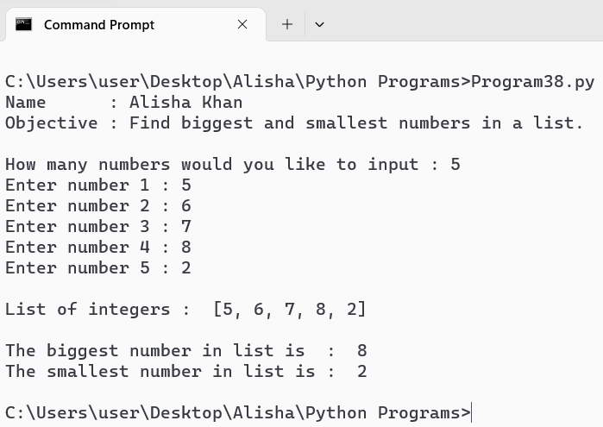

Write a Python program to find common elements in two lists.
Code :
print("Name : Alisha Khan")
print("Objective : Find common elements in two lists.")
print()

def find(list1, list2) :
common = []
for element in list1 :
if element in list2 and element not in common :
common.append(element)
return common

n1 = int(input("How many numbers would you like to input for first list : "))
list1 = []
for i in range(n1) :
num = int(input(f"Enter number {i+1} : "))
list1.append(num)

n2 = int(input("\nHow many numbers would you like to input for second list : "))
list2 = []
for i in range(n2) :
num = int(input(f"Enter number {i+1} : "))
list2.append(num)

common = find(list1, list2)
print("\nThe common elements in both lists are : ", common)

Output :

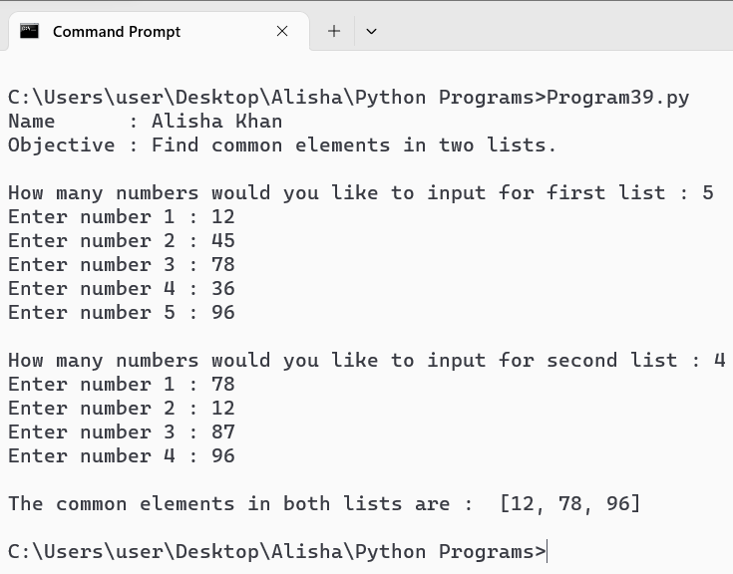

Write a Python program to demonstrate the various tuple processing methods.
Code :
print("Name : Alisha Khan")
print("Objective : Demonstrate various tuple processing methods.")
print()
def processing() :
my_tuple = (1, 2, 3, 4, 5)
print("Original tuple : ", my_tuple)

print("\nFirst element : ", my_tuple[0])
print("Second element : ", my_tuple[1])

print("\nSlicing form index 1 to 3 : ", my_tuple[1:4])

another_tuple = (6, 7, 8)
concat = my_tuple + another_tuple
print("\nConcatenated tuple : ", concat)

print("\nLength of the original tuple : ", len(my_tuple))

count = my_tuple.count(3)
print("\nNumber of times 3 appears in the tuple : ", count)

index = my_tuple.index(4)
print("\nIndex of the first occurance of 4 : ", index)

print("\nMaximum value in the tuple : ", max(my_tuple))
print("Minimum value in the tuple : ", min(my_tuple))
print("Sum of all elements in the tuple : ", sum(my_tuple))
processing()

Output :

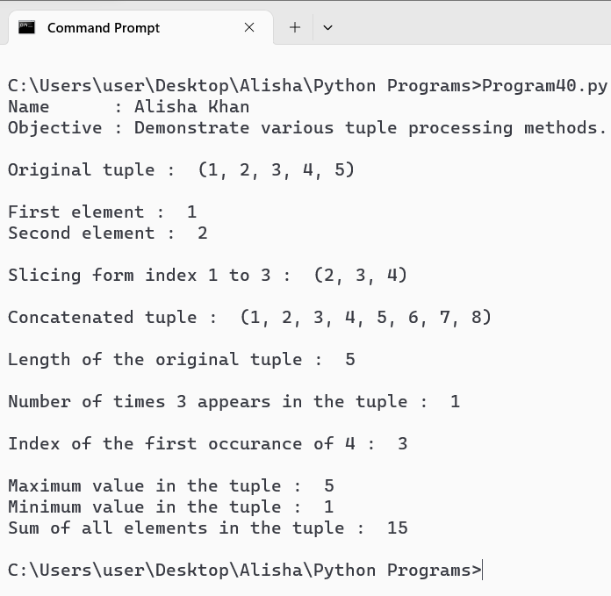

Write a Python program to demonstrate the use of dictionaries.
Code :
print("Name : Alisha Khan")
print("Objective : Demonstrate use of Dictionary.")
print()
person = {
"Name ": "Alisha",
"Age ": 22,
"City ": "Raipur",
"Email": "alishakhan8210@gmail.com"
}
print("Initial Dictionary : ")
for key, value in person.items() :
print(f"{key} : {value}")

person["age "] = 21
person["city "] = "Dongergaon"
person["phone"] = "1234567890"

print("\nModified Dictionary : ")
for key, value in person.items():
print(f"{key} : {value}")

del person["Email"]

print("\nDictionary after removing email : ")
for key, value in person.items() :
print(f"{key} : {value}")

Output :

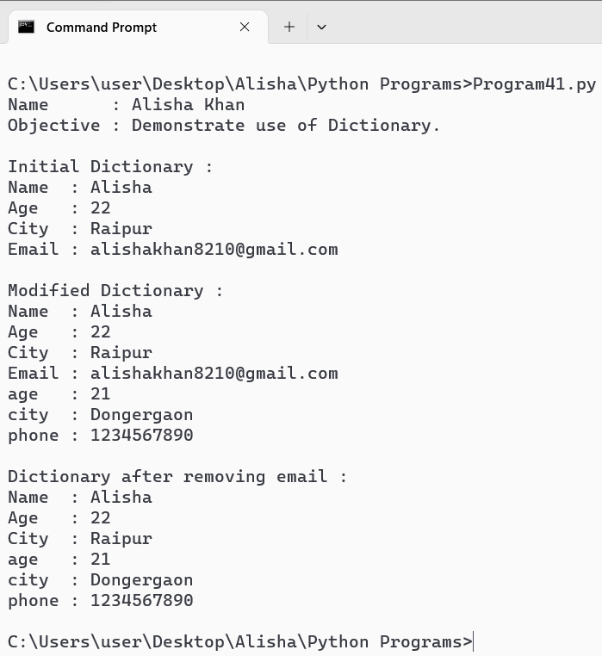

Write a Python program to find the number of occurrences of each letter in a string using
dictionaries.
Code :
print("Name : Alisha Khan")
print("Objective : find the occurrence of each letter in a string using Dictionary.")
print()
def occur(string) :
letter_count = {}

for char in string :
char = char.lower()
if char.isalpha() :
if char in letter_count :
letter_count[char] += 1
else :
letter_count[char] = 1
return letter_count

input_string = input("Enter a string : ")
occurrence = occur(input_string)

print("\nLetter Occurence : ")
for letter, count in occurrence.items() :
print(f"The letter '{letter}' comes {count} times.")

Output :

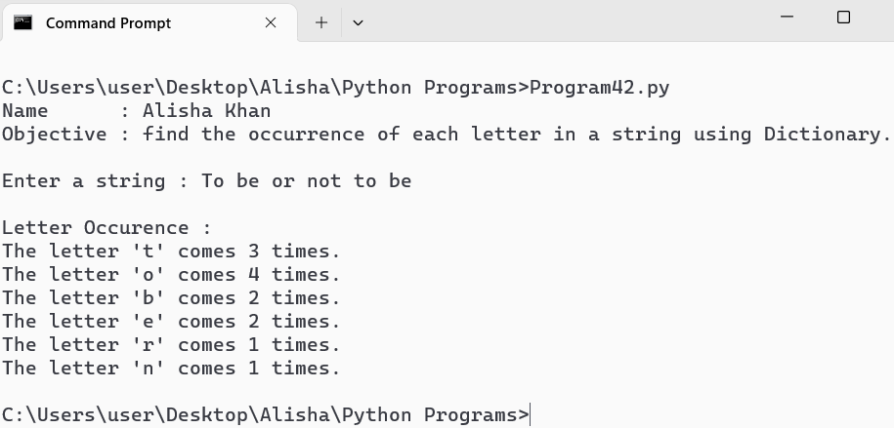

Write a Python program to print the CWD and change the CWD.

Code :
print("Name : Alisha Khan")
print("Objective : Print the CWD and change the CWD.")
print()

import os
def print_cwd() :
cwd = os.getcwd()
print("Current Working Directory : ", cwd)

def change_cwd(new_path) :
try :
os.chdir(new_path)
print("Changed to new Working Directory : ", os.getcwd())
except Exception as e :
print("Error : ", e)

print_cwd()

new_path = input("Enter the path to change the CwD to : ")
change_cwd(new_path)
print_cwd

Output :

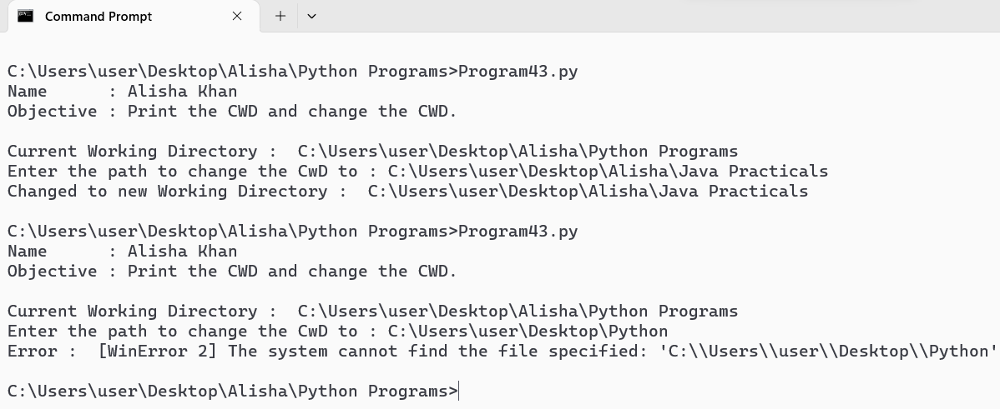

Write a Python program that takes a list of words from the user and writes them into a file. The
program should stop when the user enters the word ‘quit’.

Code :
print("Name : Alisha Khan")
print("Objective : Take list of words and write them into a file.")
print()

def write_to_file(filename) :
with open(filename, 'w') as file :
print("Enter words to write to a file. \nType 'quit' to stop. ")
while True :
word = input("Enter a word : ")
if word.lower() == 'quit' :
break
file.write(word + '\n')

def read_from_file(filename) :
print("\nContents of the file : ")
with open(filename, 'r') as file :
for line in file :
print(line.strip())

filename = 'words.text'

write_to_file(filename)
read_from_file(filename)

print(f"\nThe words have been written to {filename} and displayed above.")

Output :

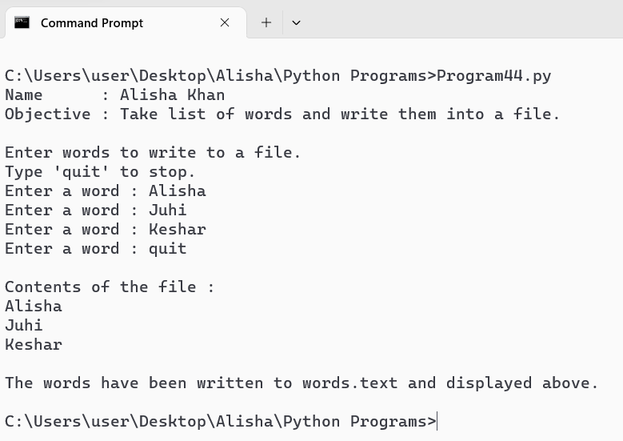

Write a Python program that reads a file in text mode and counts the number of words that
contain anyone of the letters [‘w’, ‘o’, ‘r’, ‘d’, ‘s’].

Code :
print("Name : Alisha Khan")
print("Objective : Read file in text mode and count number of words.")
print()
def countwords(filename) :
specific = set('words') #defining set of specific letters to look for
count = 0
with open(filename, 'r') as file :
content = file.read()
print("File content : \n")
print(content)
file.seek(0) #reset file pointer to the beginning of file
for line in file :
words = line.split() #split line into words
for word in words :
#check if any of the specific letters are in the word
if any(letter in word for letter in specific) :
count += 1
return count
#specify file name
filename = 'input.txt'

count = countwords(filename)
print(f"\nThe number of words containing any of the letters ['w', 'o', 'r', 'd', 's'] is : {count}")

Output :

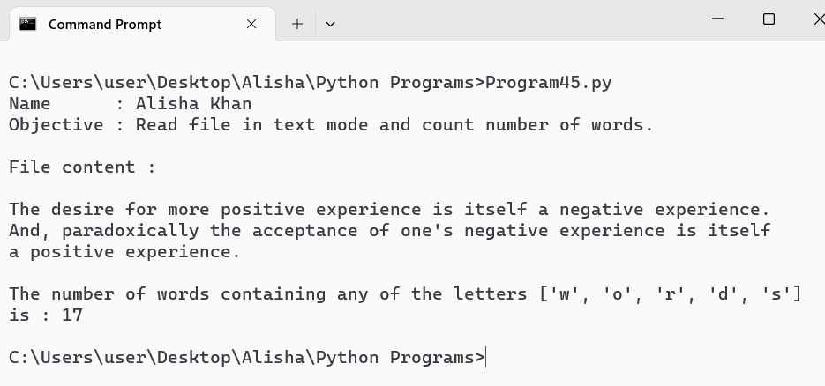

Python programs to demonstrate the creation and use of “modules”.

Code :
#mymodule
def add(a, b) :
return a + b
def subtract(a, b) :
return a - b
def multiply(a, b) :
return a * b
def divide(a, b) :
if b == 0 :
raise ValueError("Cannot divide by zero !!")
return a / b

#Program
import mymodule

print("Name : Alisha Khan")
print("Objective : Demonstrate the creatiion and use of modules.")
print()

a = int(input("Enter the value of A : "))
b = int(input("Enter the value of B : "))

print(f"\nAdd : {a} + {b} = {mymodule.add(a, b)}")
print(f"Subtract : {a} - {b} = {mymodule.subtract(a, b)}")
print(f"Multiply : {a} * {b} = {mymodule.multiply(a, b)}")
print(f"Divide : {a} / {b} = {mymodule.divide(a, b)}")

Output :

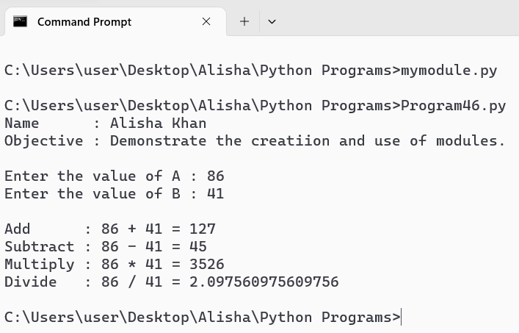

Exception Handling Program that uses try and except.

Code :
print("Name : Alisha Khan")
print("Objective : Except handling program using try and except.")
print()
def main() :
try :
numerator = float(input("Enter the Numerator : "))
denominator = float(input("Enter the Denominator : "))

result = numerator / denominator
print("Result : ", numerator, "/ ", denominator, " : ", result)

except ZeroDivisionError :
print("Error : Cannot divide by Zero !!")
except ValueError :
print("Error : Please enter valid numbers.")

main()

Output :

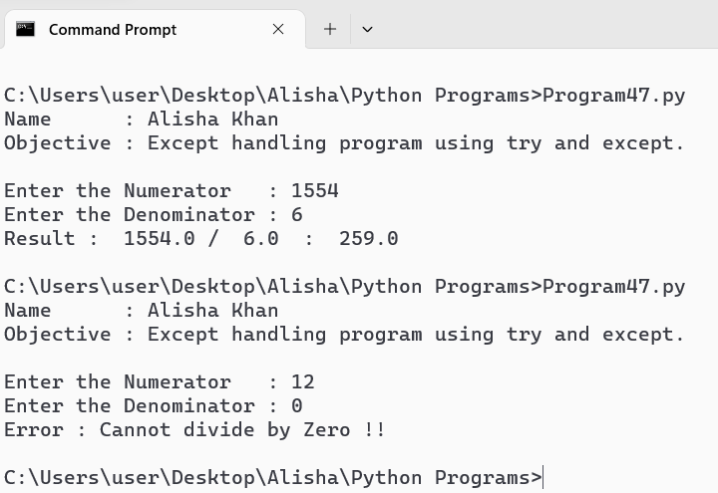

Exception Handling Program that handles multiple types of exceptions.

Code :
print("Name : Alisha Khan")
print("Objective : Handling multiple types of exception.")
print()
def read_file(file_path) :
try :
with open(file_path, 'r') as file :
content = file.read()
print("File content : \n ", content)
except FileNotFoundError :
print("Error : File not found at the specified path.")
except PermissionError :
print("Error : Permission denied to read the file.")
except Exception as e :
print("An unexpected error occured : ", e)

def main() :
file_path = input("Enter the path of the file to read : ")
read_file(file_path)

main()

Output :

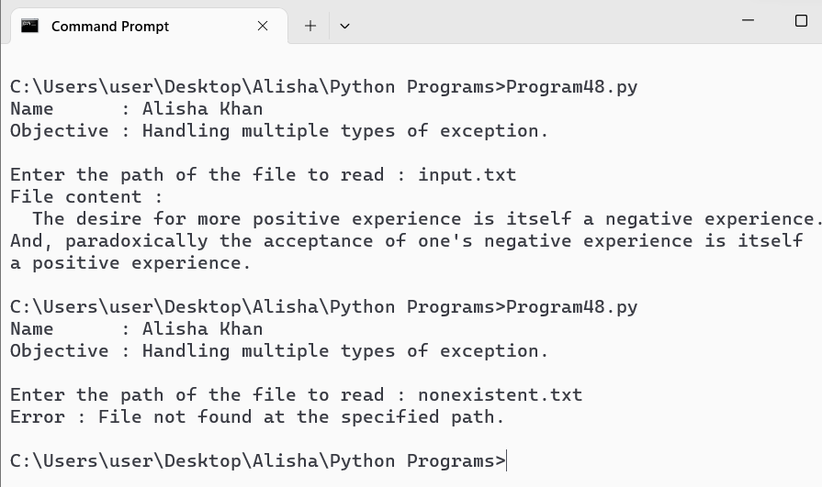

Exception Handling Program that uses try, except and else.

Code :
print("Name : Alisha Khan")
print("Objective : Use of try, excrept and else.")
print()
def calculate_square_root():
try:
number = float(input("Enter a number to calculate its square root: "))
if number < 0:
raise ValueError("Cannot calculate square root of a negative number")
result = number ** 0.5
except ValueError as ve:
print(f"Error: {ve}")
except Exception as e:
print(f"An unexpected error occurred: {e}")
else:
print(f"The square root of {number} is {result:.2f}")

# Test cases
calculate_square_root()

Output :

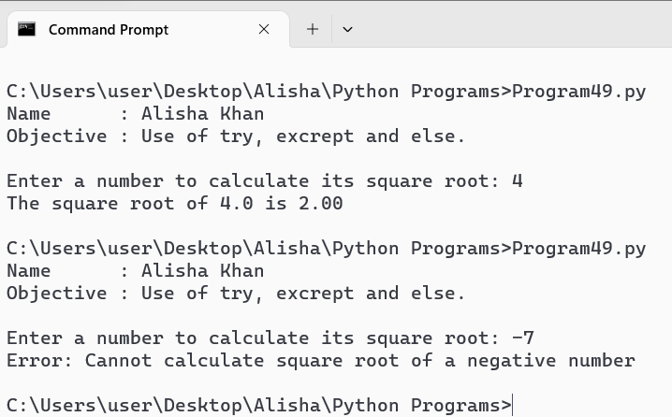

Exception Handling Program that uses finally with try.

Code :
print("Name : Alisha Khan")
print("Objective : Exception handling using finally with try.")
print()
class BankAccount:
def __init__(self):
self.balance = 0
def deposit(self, amount):
if amount > 0:
self.balance += amount
def withdraw(self, amount):
if amount > 0 and amount <= self.balance:
self.balance -= amount

b = BankAccount()
while True:
c = input("1. Deposit\n2. Withdraw\n3. Check Balance\n4. Exit\n\nEnter your choice (1-4): ")
try:
if c == '1':
b.deposit(float(input("Enter the amount to deposit: ")))
elif c == '2':
b.withdraw(float(input("Enter the amount to withdraw: ")))
elif c == '3':
print(f"Your current balance is ${b.balance}.")
elif c == '4':
print("Thank you for using our banking service.")
break
else:
print("Invalid choice. Please enter a number between 1 and 4.")
except ValueError as e:
print(f"Error: {e}")
finally :
print("Action Completed.")

Output :

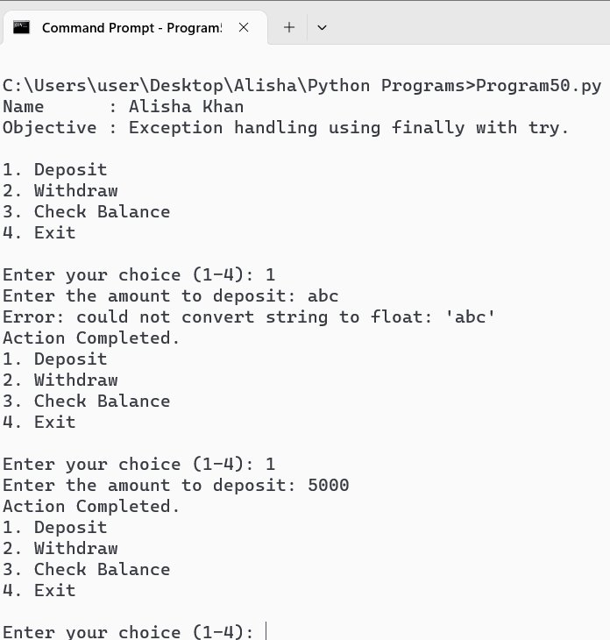

Write a Python program that creates a class “Person”, with attributes [aadhar, name, DoB]

Code :
print("Name : Alisha Khan")
print("Objective : Create a class Person with given attributes.")
print()
class Person :
def __init__(self, aadhar, name, DOB) :
self.aadhar = aadhar
self.name = name
self.DOB = DOB

aadhar = input("Enter Aadhar Number : ")
name = input("Enter Name : ")
DOB = input("Enter Date Of Birth (YYYY-MM-DD) : ")

obj = Person(aadhar, name, DOB)
print("\nPerson Details : ")
print("Aadhar : ", obj.aadhar)
print("Name : ", obj.name)
print("Date of Birth : ", obj.DOB)

Output :

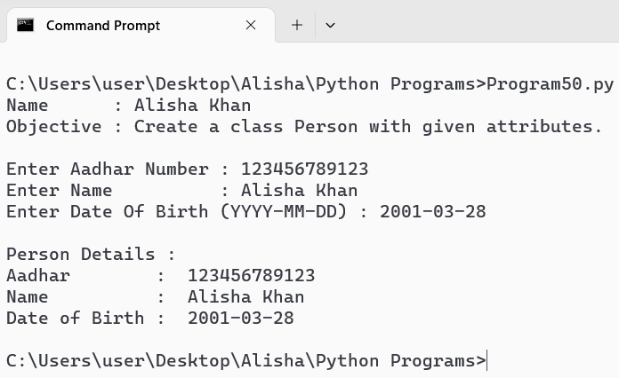

Write a Python program that creates classes “Point” and “Rectangle” where the Rectangle class has a Point object as its attribute.
Code :
print("Name : Alisha Khan")
print("Objective : One class having another class’s object as its attribute.")
print()
class Point :
def __init__(self, x, y) :
self.x = x
self.y = y
def __str__(self):
return f"({self.x}, {self.y})"

class Rectangle :
def __init__(self, point1, point2) :
self.point1 = point1
self.point2 = point2

def width(self) :
return abs(self.point2.x - self.point1.x)
def height(self) :
return abs(self.point2.y - self.point1.y)

#two pointer objects to represent opposite corners of rectangle
Pointobj1 = Point(1, 2)
Pointobj2 = Point(6, 6)

RectObj = Rectangle(Pointobj1, Pointobj2)

print("Rectangle class has Point objects as its attributes.")
print(f"Point 1: {Pointobj1}")
print(f"Point 2: {Pointobj2}")
print("\nRectangle Dimensions:")
print("Width : ",RectObj.width())
print("Height : ",RectObj.height())

Output :

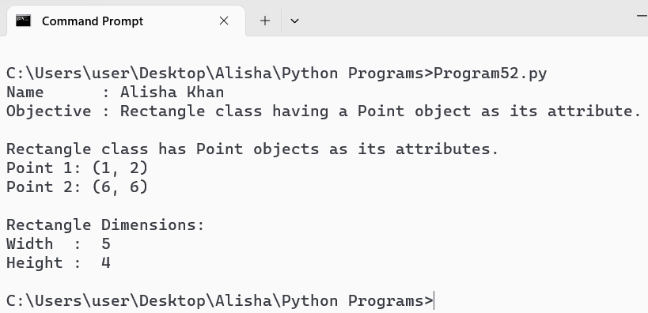

Write a Python program that creates a class Students which inherits the properties of the “Person” class; add attributes [roll_no, class].
Code :
print("Name : Alisha Khan")
print("Objective : Single Inheritance.")
print()
class Person :
def __init__(self, name, age) :
self.name = name
self.age = age

def display(self) :
print("Name : ", self.name)
print("Age : ", self.age)
class Student :
def __init__(self, name, age, roll_no, class_name) :
Person.__init__(self, name, age)
self.roll_no = roll_no
self.class_name = class_name

def display(self) :
Person.display(self)
print("Roll No. : ", self.roll_no)
print("Class : ", self.class_name)

#user input
name = input("Enter Name : ")
age = input("Enter Age : ")
roll_no = input("Enter Roll No. : ")
class_name = input("Enter Class Name : ")

print("\nDisplay Student Details :")
studentObj = Student(name, age, roll_no, class_name)
studentObj.display()

Output :

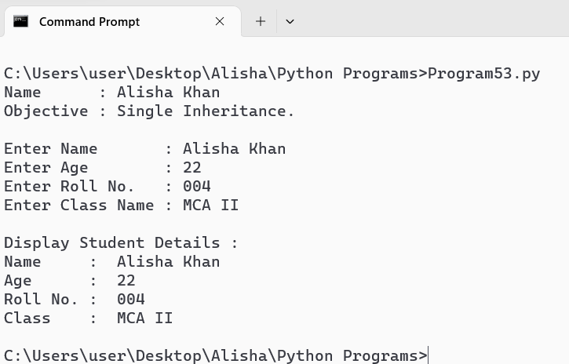

Write a Python program to demonstrate “Multiple Inheritance”.

Code :
print("Name : Alisha Khan")
print("Objective : Demonstrate Multiple Inheritance.")
print()
class Library :
def __init__(self) :
self.book = []

def add_book(self, book) :
self.book.append(book)
print("Book ", book, " added to the library.")

def display_books(self) :
print("Books available in the library : ")
for book in self.book :
print("_", book)

class Bookstore :
def __init__(self) :
self.book_for_sale = []

def add_for_sale(self, book) :
self.book_for_sale.append(book)
print("Book ", book, " added for sale : ")

def display_sale(self) :
print("Books available for sale : ")
for book in self.book_for_sale :
print("_", book)

class Bookshop(Library, Bookstore) :
def __init__(self) :
Library.__init__(self)
Bookstore.__init__(self)

def display_all(self) :
print("\nAll books available : ")
print("==");
self.display_books()
print("---")
self.display_sale()

def main() :
bookshop = Bookshop()

book_title = input("Enter the title of the book to add to the library: ")
bookshop.add_book(book_title)

book_title = input("\nEnter the title of the book to add for sale: ")
bookshop.add_for_sale(book_title)

bookshop.display_all()

main()

Output :

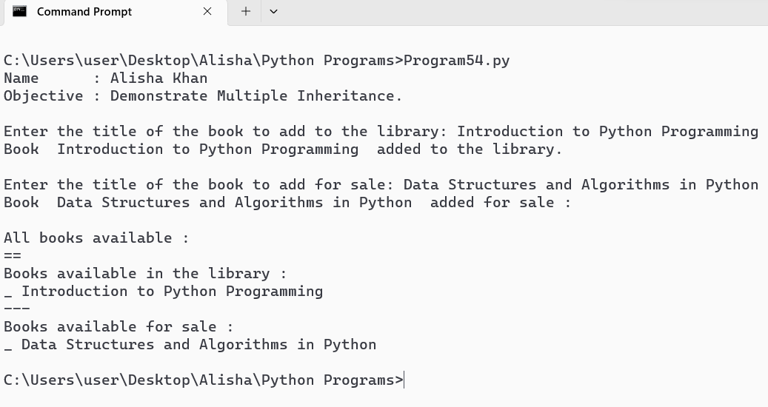

Write a Python program to demonstrate “Method Overriding”.

Code :
print("Name : Alisha Khan")
print("Objective : Demonstrate Method Overriding.")
print()
class Shape :
def area(self) :
return 0;

class Rectangle(Shape) :
def __init__(self, width, height) :
self.width = width
self.height = height

def area(self) :
return self.height * self.width

class Circle(Shape) :
def __init__(self, radius) :
self.radius = radius

def area(self) :
return 3.14 * self.radius * self.radius

RectangleObj = Rectangle(5, 6)
CircleObj = Circle(5)
print("Displlay Area :")
print("Area of Rectangle : ", RectangleObj.area())
print("Area of Circle : ", CircleObj.area())

Output :

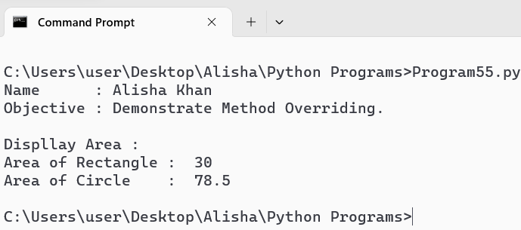

Write a Python program to demonstrate “Method Overloading”.

Code :
print("Name : Alisha Khan")
print("Objective : Demonstrate Method Overloading.")
print()

from multipledispatch import dispatch

@dispatch(int, int)
def product(first, second) :
result = first * second
print(f"Product of {first} and {second} : {result}")

@dispatch(int, int, int)
def product(first, second, third) :
result = first * second * third
print(f"\nProduct of {first}, {second} and {third} : {result}")

@dispatch(float, float, float)
def product(first, second, third) :
result = first * second * third
print(f"\nProduct of {first}, {second} and {third} : {result}")

product(2, 3)
product(2, 3, 4)
product(2.2, 3.4, 2.3)

Output :

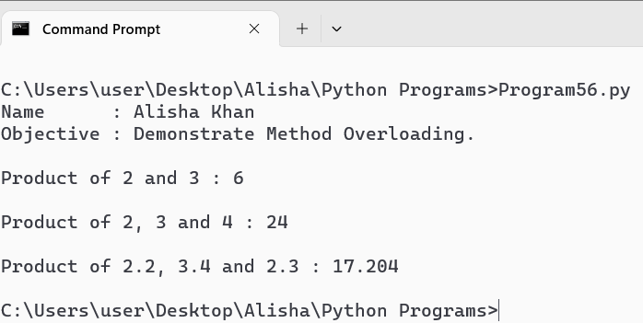

Write a Python program to demonstrate “Operator Overloading” [+ and -] using a class “Book”.

Code :
print("Name : Alisha Khan")
print("Objective : Operator Overloading [+ and -] using a class Book.")
print()

class Book:
def __init__(self, title, author, pages):
self.title = title
self.author = author
self.pages = pages

def __add__(self, other):
total_pages = self.pages + other.pages
return f"Total pages of '{self.title}' by {self.author} and '{other.title}' by {other.author} is {total_pages}"

def __sub__(self, other):
difference = abs(self.pages - other.pages)
return f"\nDifference in pages between '{self.title}' by {self.author} and '{other.title}' by {other.author} is {difference}"

book1 = Book("Python Programming", "John Smith", 350)
book2 = Book("Data Structures and Algorithms", "Alice Johnson", 500)

print(book1 + book2)
print(book1 - book2)

Output :

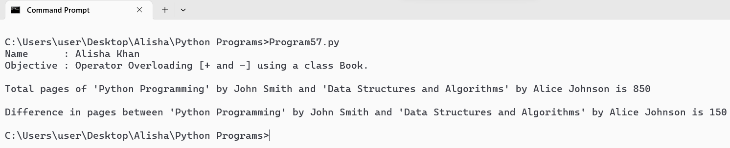

Use the “turtle” module to draw concentric circles with different colours.

Code :
print("Name : Alisha Khan")
print("Objective : Draw concentric circles with different colours.")
print()

import turtle
t = turtle.Turtle()

colors = ['red', 'yellow', 'orange', 'pink', 'blue', 'purple', 'green', 'black']
radius = 10
t.pensize(2)

for i in range(12) :
t.pencolor(colors[i%7])
radius += 20
t.penup()
t.goto(0, -radius)
t.pendown()
t.circle(radius)

turtle.mainloop()
turtle.done()

Output :

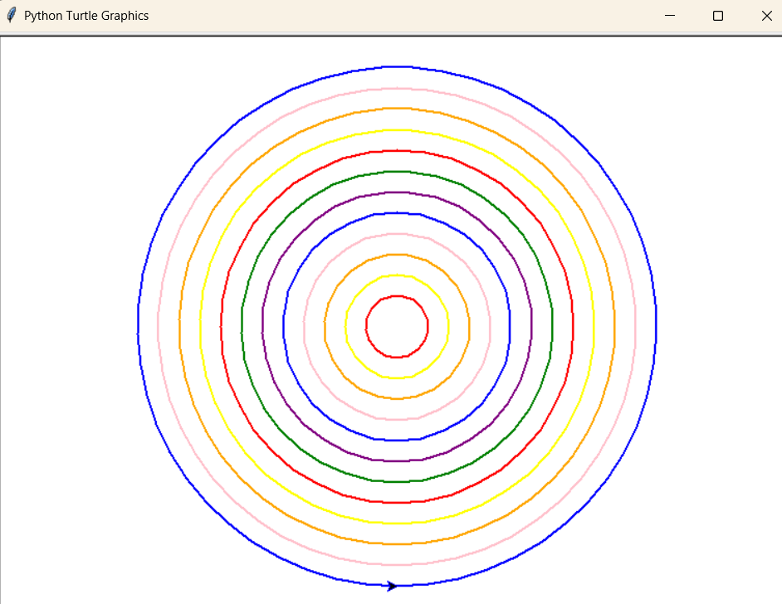

Use the “turtle” module to print the multiplication table.

Code :
print("Name : Alisha Khan")
print("Objective : turtle module to print multiplication table.")
print()

import turtle
t = turtle.Turtle()

x, y = -500, 200
t.penup()
t.goto(x, y)
t.pendown()

FONT_SIZE = 12
FONT_STYLE = ("Arial", FONT_SIZE, "normal")
VERTICAL_OFFSET = 30

for i in range(1, 11):
for j in range(1, 11):
product = i * j
t.write(f"{i} x {j} = {product}", font=FONT_STYLE, align = "left")
t.penup()
t.goto(x, y - VERTICAL_OFFSET * j)
t.pendown()

x += 100
t.penup()
t.goto(x, y)
t.pendown()

t.hideturtle()
turtle.done()

Output :

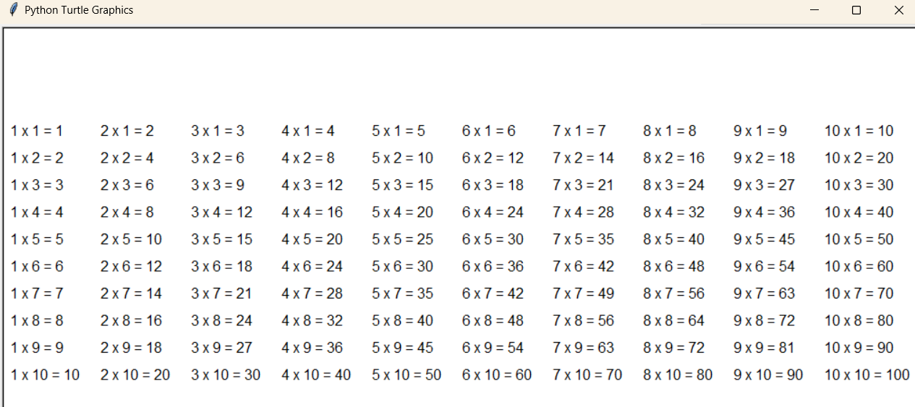

Use the “turtle” module to draw (not write) your name.

Code :
print("Name : Alisha Khan")
print("Objective : Use turtle module to draw your name.")
print()

import turtle
t = turtle.Turtle()

t.width(5)
t.penup()
t.goto(-300,0)
t.pendown()

#Draw A
def A() :
t.left(75)
t.forward(150)
t.right(150)
t.forward(150)
t.backward(60)
t.right(105)
t.forward(50)

A()

#Draw L
t.penup()
t.goto(-200, 0)
t.pendown()
t.right(90)
t.forward(140)
t.backward(140)
t.right(90)
t.forward(60)

#Draw I
t.penup()
t.goto(-120, 0)
t.pendown()
t.forward(70)
t.backward(35)
t.left(90)
t.forward(140)
t.left(90)
t.forward(35)
t.right(180)
t.forward(70)

#Draw S
t.penup()
t.goto(-25, 0)
t.pendown()
t.forward(70)
t.left(90)
t.forward(70)
t.left(90)
t.forward(70)
t.right(90)
t.forward(70)
t.right(90)
t.forward(70)

#Draw H
t.penup()
t.goto(70, 0)
t.pendown()
t.left(90)
t.forward(140)
t.backward(70)
t.right(90)
t.forward(60)
t.left(90)
t.forward(70)
t.backward(140)

#Draw A
t.penup()
t.goto(150, 0)
t.pendown()
t.right(90)
A()

t.hideturtle()
turtle.done()

Output :

